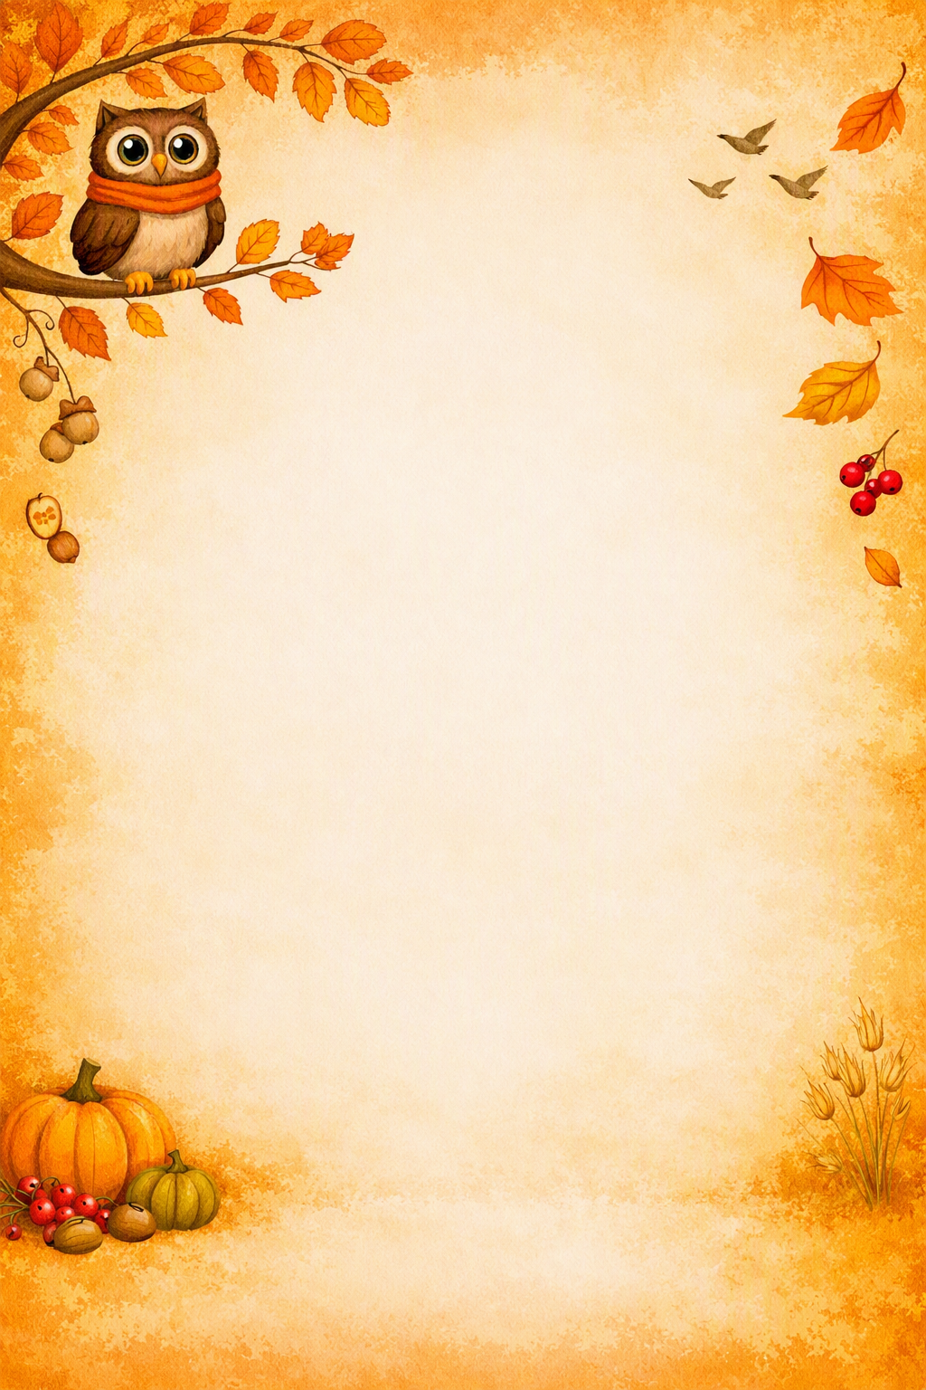
Welcome back to the Autumn term. I hope you have all had a wonderful break. I can’t wait to hear all about it!
Welcome to Year 5!
If you or your child have any questions or concerns, please do not hesitate to get in touch.
My email address is: v.wynne@crackleybank.staffs.sch.uk

Curriculum
During the Autumn term, we will start our Maths unit with place value. We be reading and writing about our brand-new Guided Reading book – I can’t wait to share it with you! Our Geography unit will be all about hills! In Science, we will be learning all about space and forces! In PSHE, we will be learning about stereotypes and what makes a person’s identity. We will also be refining our sketching skills in Art – what an exciting term! All Crucial Knowledge can be found on our class page on the school website: https://www.crackleybank.staffs.sch.uk/index.php/year-5

Reading
Reading books and diaries need to come into school each day. Your child should be reading at home with an adult regularly. Please sign their reading diary when they do.
PE
PE will take place on a Monday and Wednesday. On these days, children need to come into school in their school PE kit and stay in them all day. Please ensure children have suitable trainers. Children must wear their long hair tied back and they will not be able to wear earrings. Plasters will not be accepted.
As part of their PE learning, Year 5 will be going swimming at CCSC every Wednesday afternoon starting in the next few weeks. We will be sending out more details regarding this soon, but if you have any questions, please do not hesitate to ask.
Homework
Homework will be given out on a Thursday in paper form. It will need to be back in school for the following Wednesday. Homework consists of Fast Maths, spellings, reading and Maths Whizz.

Lunches
Please send your child in with a healthy snack for break time. School lunches are £2.99. Find the menu here: https://www.crackleybank.staffs. sch.uk/index.php/parent information/lunch-menu

Weather
As the weather is very unpredictable this time of year, please ensure that your child comes to school prepared (coat, sun hat, sun cream… or all of the above!)
Water bottles
A polite reminder that water bottles need to be taken home each day, washed and returned to school the following day please.

I am looking forward to the Autumn term learning with you all!
Mrs Wynne

